Preparation of Papers for the Symposium

(Mar 2024)
First A. Author, Second B. Author, Jr., and Third C. Author
Email address here
Abstract—These instructions give you guidelines for preparing papers for IEEE TRANSACTIONS and JOURNALS. Use this document as a template if you are using Microsoft Word 6.0 or later. Otherwise, use this document as an instruction set. The electronic file of your paper will be formatted further at IEEE. Define all symbols used in the abstract. Do not cite references in the abstract. Do not delete the blank line immediately above the abstract; it sets the footnote at the bottom of this column.

Index Terms—About four-six key words or phrases in alphabetical order, separated by commas. For a list of suggested keywords, send a blank e-mail to keywords@ieee.org or visit http://www.ieee.org/organizations/pubs/ani_prod/keywrd98.txt

INTRODUCTION
T
HIS document is a template for Microsoft Word versions 6.0 or later. If you are reading a paper or PDF version of this document, please download the electronic file,
TRANS-JOUR.DOC, from the IEEE Web site at http://www.ieee.org/web/publications/authors/transjnl/index.html so you can use it to prepare your manuscript. If you would prefer to use LATEX, download IEEE’s LATEX style and sample files from the same Web page. Use these LATEX files for formatting, but please follow the instructions in TRANS-JOUR.DOC or TRANS-JOUR.PDF.
If your paper is intended for a conference, please contact your conference editor concerning acceptable word processor formats for your particular conference.

Procedure for Paper Submission
Please check with your editor on whether to submit your manuscript as hard copy or electronically for review. If hard copy, submit photocopies such that only one column appears per page. This will give your referees plenty of room to write comments. Send the number of copies specified by your editor (typically four). If submitted electronically, find out if your editor prefers submissions on disk or as e-mail attachments.
IUnder the option EDIT select PASTE SPECIAL. A dialog box will open, select paste picture, then click OK. Your figure should now be in the Word Document.
If you are preparing images in TIFF, EPS, or PS format, note the following. High-contrast line figures and tables should be prepared with 600 dpi resolution and saved with no compression, 1 bit per pixel (monochrome), with file names in the form of “fig3.tif” or “table1.tif.”
Photographs and grayscale figures should be prepared with 300 dpi resolution and saved with no compression, 8 bits per pixel (grayscale).

Print Color Graphics Requirements
IEEE accepts color graphics in the following formats: EPS, PS, TIFF, Word, PowerPoint, Excel, and PDF. The resolution of a RGB color TIFF file should be 400 dpi.
When sending color graphics, please supply a high quality hard copy or PDF proof of each image. If we cannot achieve a satisfactory color match using the electronic version of your files, we will have your hard copy scanned. Any of the files types you provide will be converted to RGB color EPS files.

Web Color Graphics
IEEE accepts color graphics in the following formats: EPS, PS, TIFF, Word, PowerPoint, Excel, and PDF. The resolution of a RGB color TIFF file should be at least 400 dpi.
Your color graphic will be converted to grayscale if no separate grayscale file is provided. If a graphic is to appear in print as black and white, it should be saved and submitted as a black and white file. If a graphic is to appear in print or on IEEE Xplore in color, it should be submitted as RGB color.
Graphics Checker Tool
The IEEE Graphics Checker Tool enables users to check graphic files. The tool will check journal article graphic files against a set of rules for compliance with IEEE requirements. These requirements are designed to ensure sufficient image quality so they will look acceptable in print. After receiving a graphic or a set of graphics, the tool will check the files against a set of rules. A report will then be e-mailed listing each graphic and whether it met or failed to meet the requirements. If the file fails, a description of why and instructions on how to correct the problem will be sent. The IEEE Graphics Checker Tool is available at http://graphicsqc.ieee.org/
For more Information, contact the IEEE Graphics H-E-L-P Desk by e-mail at graphics@ieee.org. You will then receive an e-mail response and sometimes a request for a sample graphic f
TABLE I
Units for Magnetic Properties
Symbol | Quantity | Conversion from Gaussian and  CGS EMU to SI ª
Φ | magnetic flux | 1 Mx → 10⁻⁸ Wb = 10⁻⁸ V·s
B | magnetic flux density,  magnetic induction | 1 G → 10⁻⁴ T = 10⁻⁴ Wb/m²
H | magnetic field strength | 1 Oe → 10³/(4π) A/m
m | magnetic moment | 1 erg/G = 1 emu  → 10⁻³ A·m² = 10⁻³ J/T
M | magnetization | 1 erg/(G·cm³) = 1 emu/cm³  → 10³ A/m
4πM | magnetization | 1 G → 10³/(4π) A/m
σ | specific magnetization | 1 erg/(G·g) = 1 emu/g → 1 A·m²/kg
j | magnetic dipole  moment | 1 erg/G = 1 emu  → 4π × 10⁻¹⁰ Wb·m
J | magnetic polarization | 1 erg/(G·cm³) = 1 emu/cm³  → 4π × 10⁻⁴ T
χ, κ | susceptibility | 1 → 4π
χ_{ρ} | mass susceptibility | 1 cm³/g → 4π × 10⁻³ m³/kg
μ | permeability | 1 → 4π × 10⁻⁷ H/m  = 4π × 10⁻⁷ Wb/(A·m)
μ_{r} | relative permeability | μ → μ_{r}
w, W | energy density | 1 erg/cm³ → 10⁻¹ J/m³
N, D | demagnetizing factor | 1 → 1/(4π)
Vertical lines are optional in tables. Statements that serve as captions for the entire table do not need footnote letters.
ªGaussian units are the same as cgs emu for magnetostatics; Mx = maxwell, G = gauss, Oe = oersted; Wb = weber, V = volt, s = second, T = tesla, m = meter, A = ampere, J = joule, kg = kilogram, H = henry.

MATH
If you are using Word, use either the Microsoft Equation Editor or the MathType add-on (http://www.mathtype.com) for equations in your paper (Insert | Object | Create New | Microsoft Equation or MathType Equation). “Float over text” should not be selected.

Units
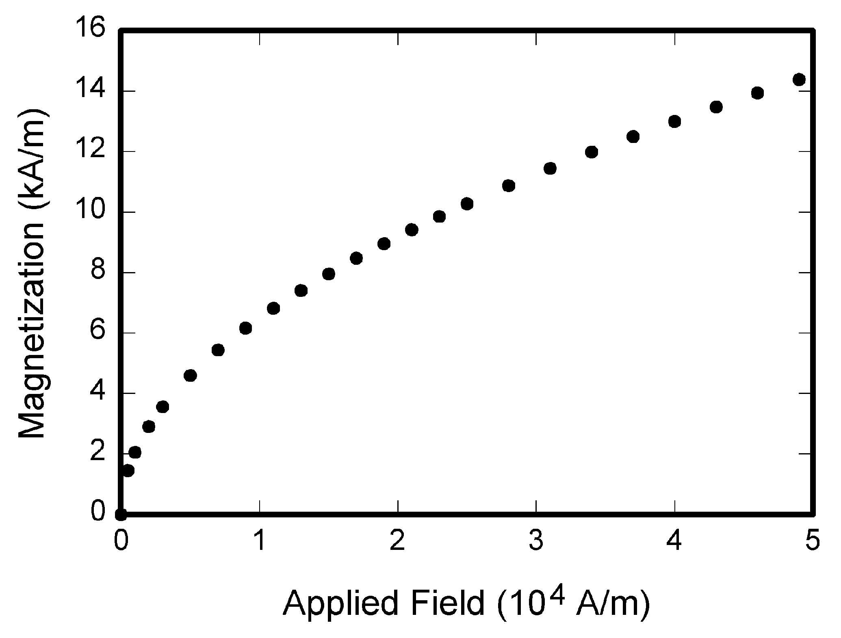
Fig. 1. Magnetization as a function of applied field. Note that “Fig.” is abbreviated. There is a period after the figure number, followed by two spaces. It is good practice to explain the significance of the figure in the caption.

Use either SI (MKS) or CGS as primary units. (SI units are strongly encouraged.) English units may be used as secondary units (in parentheses). This applies to papers in data storage. For example, write “15 Gb/cm² (100 Gb/in²).” An exception is when English units are used as identifiers in trade, such as “3½-in disk drive.” Avoid combining SI and CGS units, such as current in amperes and magnetic field in oersteds. This often leads to confusion because equations do not balance dimensionally. If you must use mixed units, clearly state the units for each quantity in an equation.
The SI unit for magnetic field strength H is A/m. However, if you wish to use units of T, either refer to magnetic flux density B or magnetic field strength symbolized as µ₀H. Use the center dot to separate compound units, e.g., “A·m².”

Conclusion
A conclusion section is not required. Although a conclusion may review the main points of the paper, do not replicate the abstract as the conclusion. A conclusion might elaborate on the importance of the work or suggest applications and extensions.

References
- G. O. Young, “Synthetic structure of industrial plastics (Book style with paper title and editor),” in Plastics, 2nd ed. vol. 3, J. Peters, Ed. New York: McGraw-Hill, 1964, pp. 15–64.
- W.-K. Chen, Linear Networks and Systems (Book style). Belmont, CA: Wadsworth, 1993, pp. 123–135.
- H. Poor, An Introduction to Signal Detection and Estimation. New York: Springer-Verlag, 1985, ch. 4.
- B. Smith, “An approach to graphs of linear forms (Unpublished work style),” unpublished.
- E. H. Miller, “A note on reflector arrays (Periodical style—Accepted for publication),” IEEE Trans. Antennas Propagat., to be published.

First A. Author (M’76–SM’81–F’87) and the other authors may include biographies at the end of regular papers. Biographies are often not included in conference-related papers. This author became a Member (M) of IEEE in 1976, a Senior Member (SM) in 1981, and a Fellow (F) in 1987. The first paragraph may contain a place and/or date of birth (list place, then date). Next, the author’s educational background is listed. The degrees should be listed with type of degree in what field, which institution, city, state, and country, and year degree was earned. The author’s major field of study should be lower-cased.
The second paragraph uses the pronoun of the person (he or she) and not the author’s last name. It lists military and work experience, including summer and fellowship jobs. Job titles are capitalized. The current job must have a location; previous positions may be listed without one. Information concerning previous publications may be included. Try not to list more than three books or published articles. The format for listing publishers of a book within the biography is: title of book (city, state: publisher name, year) similar to a reference. Current and previous research interests end the paragraph.

